Spi_int(Serial Peripheral Interface)

Configuration in STMCUBEMX:

1.Select SYS🡪serial wire.

2.Select SPI1 🡪select full duplex master.

3.Make the following changes in pinout.

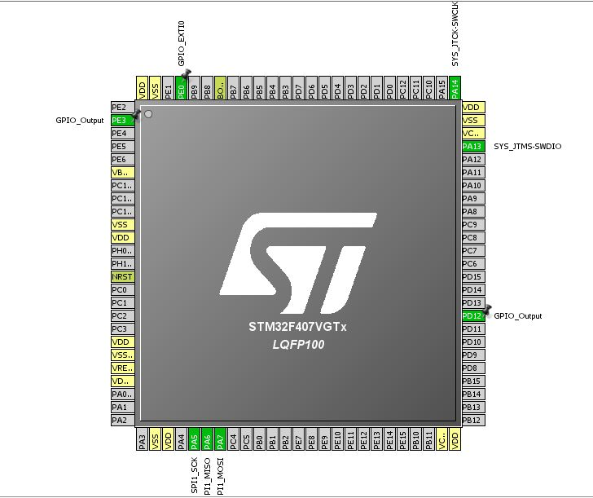

3. Click on configuration 🡪click on SPI1 🡪make the Prescale (for Bound Rate ) as 16.

4.Click on GPIO pin configuration 🡪make PE3 IS HIGH.

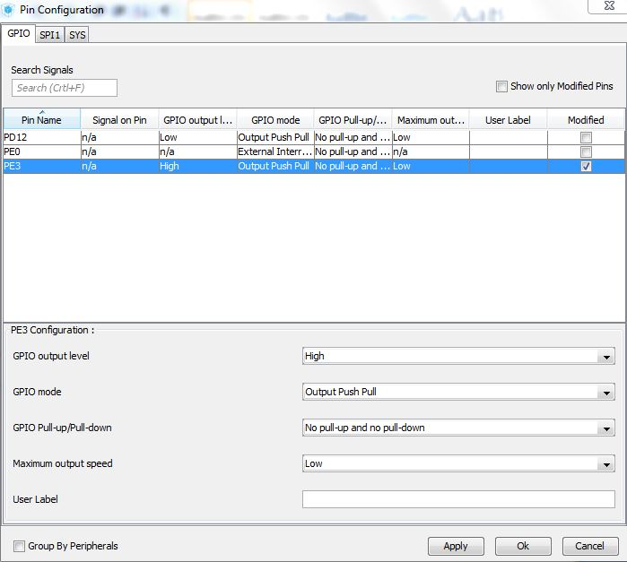

5.Click on NVIC pin configuration 🡪tick on EXTI line 0 interrupt.

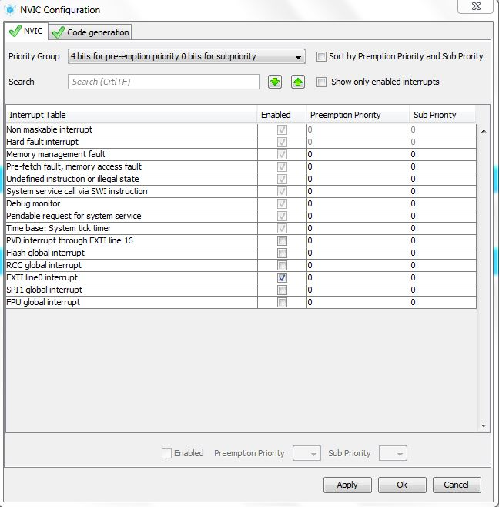

6. Then click on Apply and OK and generate code.

7. Open main.c make the following changes in code .

Define the uint8_t Rx_x[2],Rx_y[2],Rx_z[2],Return[2],TxBuf[2] in /* USER CODE BEGIN 0 */

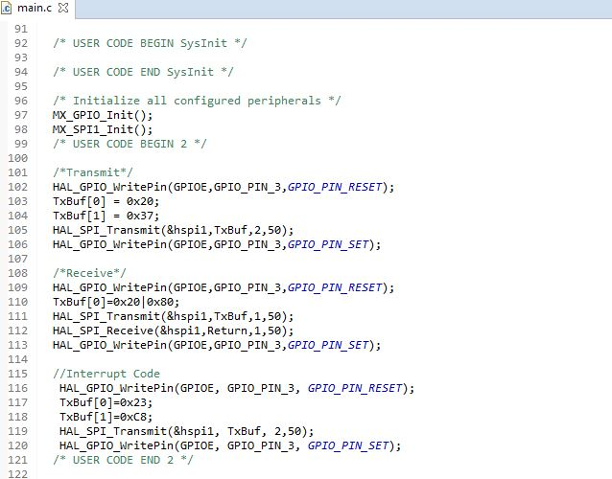

8.Build the project and Run.

